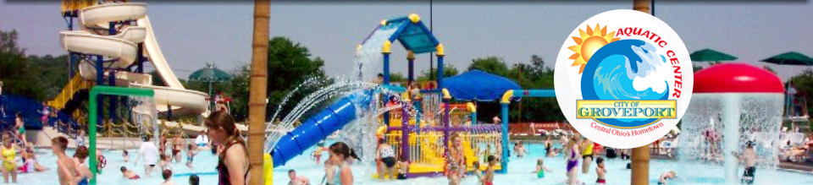

On Friday July 28th at 11:30AM the Kids will be headed for the Groveport Aquatic Center. Come join us and have some fun. We are going to leave from the church around 11:30am and will return around 3:00pm. We will provide some snacks for the kids but they should eat breakfast before leaving. We will be outside for a couple of hours so the kids should wear sun block. The cost is only $5

What to bring:
$5.00 and any extra money for snacks
Permission slip
Swim suit
Towel

If you have any questions or concerns, call Pastor Darryl cell 614-783-5935 church 614-453-5556.
Parents please keep the top portion for information

-------------------------------------------------------------------------------------------
^{DETACH HERE}
Permission and Release Form
I,______________________________________, give my permission to allow _____________________________________ to attend
^{(Parent or Guardian)} ^{(Child)}
The Groveport Aquatic Center on July 28, 2017. This is an activity of City of Refuge Baptist Church.

(Giving permission also releases City of Refuge Baptist Church from any
Liability due to injuries and/or death suffered by the participant)

Signed___________________________________________ Emergency # _____________________
^{(Parent or Guardian)}

